

* Prepared by:Muhammad Faraz, Atif

Rehman, Manahil Ahmed, Mubashir Kashif, Raahim Munir

**“** **Convert units effortlessly with our**

**accurate metric converter** **”**

**METRIC CONVERSION**



**Table Of Content**

* Acknowledgement
* Introduction
* What’s This E-Project
* Objectives of the Project
* Problem Statement
* Source Code



**Submitted to: Aptech Computer Education**

**On**

Saturday, January 4, 2025

This is to certify that Muhammad Faraz, Atif Rehman, Manahil Ahmed, Mubashir Kashif, Raahim Munir have successfully completed their ACCP Prime 2.0 1st Semester CPISM E-Project.

**Muhammad Faraz**

**Atif Rehman Mubashir Kashif**

**Manahil Ahmed Raahim Munir**

THE CERTIFICATE IS PRESENTED TO

**CERTIFICATE**

OF COMPLETION



Mass

Volume

Currency

Temperature

Length

Area

Contact Us

Calculation

FAQs

About Us

Articles

History

Home

**Metric**

**Conversion**



**Acknowledgement**

First of all we would like to thank Almighty Allah for giving us strength and ability to complete this project. And then, we would like to express our special thanks of gratitude to our teacher Sir **HABIB** and Sir **MINHAJ** who guided us on the project. They also helped us in doing a lot of **Metric Conversion**, which also helped us in doing a lot of new learning and we came to know about so many new things, we are really thankful to them. We are highly thankful to Sir **HABIB** and Sir **MINHAJ** for their guidance and constant supervision as well as for providing necessary information regarding the project & also for their support in completing the project. We also express our sincere gratitude to E-Project frame. We also express our sincere gratitude to E-Project team from Aptech Head Office, for their valuable guidance and support for the completion of this project. We hope that this project will provide all the necessary information required by the user to fulfill his/her inspiration. However, suggestion and feedback for improvements will be thankfully welcomed & acknowledged.



**Introduction**

The thirst for learning, upgrading technical skills and applying the concepts in real life environment at a fast pace is what the industry demands from IT professionals today. However busy work schedules, far-flung locations, unavailability of convenient time-slots pose as major barriers when it comes to applying the concepts into realism. And hence the need to look out for alternative means of implementation in the form of laddered approach.

The above truly pose as constraints especially for our students too! With their busy schedules, it is indeed difficult for our students to keep up with the genuine and constant need for integrated application which can be seen live especially so in the field of IT education where technology can change on the spur of a moment. Well, technology does come to our rescue at such times!!

Keeping the above in mind and in tune with our constant endeavour to use Technology in our training model, we at Aptech have thought of revolutionizing the way our students learn and implement the concepts using tools themselves by providing a live and synchronous eProject learning environment!

EProject is a step-by-step learning environment that closely simulates the classroom

and Lab based learning environment into actual implementation. It is a project

implementation at your fingertips!! An electronic, live juncture on the machine that

allows you to

* Practice step by step i.e. laddered approach.
* Build a larger more robust application.
* Usage of certain utilities in applications designed by user.
* Single program to unified code leading to a complete application.
* Learn implementation of concepts in a phased manner.
* Enhance skills and add value.
* Work on real life projects.
* Give a real life scenario and help to create applications more complicated and useful.
* Mentoring through email support.

The students at the centre are expected to complete this eProject and send complete project along with the documentation to eProjects Team

Looking forward to a positive response from your end!!

**What’s This E-Project**





**Objectives of the Project**

The Objective of this program is to give a sample project to work on real life

projects. These applications help you build a larger more robust application.

The objective is not to teach you JavaScript/Dreamweaver but to provide you with a

real life scenario and help you create basic applications using the tools.

You can revise the chapters before you start with the project.

This project is meant for students who have completed the module of ***Dreamweaver***. These programs should be done in the Lab sessions with assistance of the faculty if required.

It is very essential that a student has a clear understanding of the subject. Students

should go through the project and solve the assignments as per requirements given.

Kindly get back to eProjects Team in case of any doubts regarding the application or

its objectives.

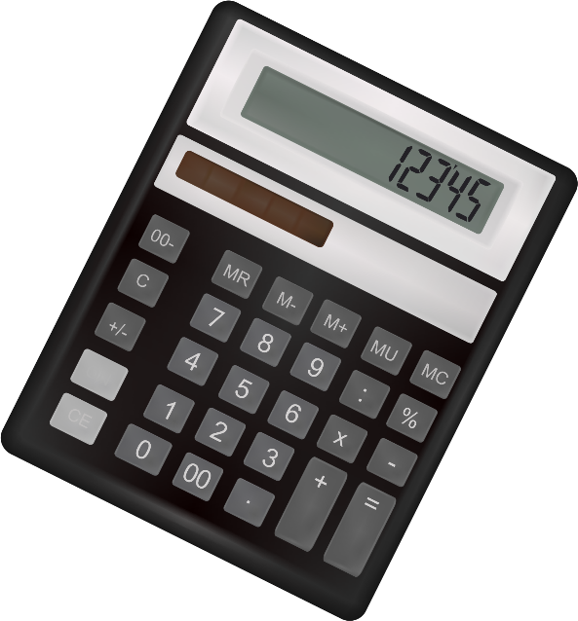



Why does one need metric conversion for? Science projects seem more authoritative

when the units used are metric units, such as grams, milliliters, and degrees Celsius.

Anyone can do good backyard science with inches and ounces, but when he shows

his work in a science fair, metric conversion will show that he understand the

importance of these units to scientists.

There are various units of measurement; one of the earliest types of measurement

concerned that of length. Many times we need to convert some data from one unit to

other. Hence you are expected to develop a calculator for such metric conversions.

Customer expectations:

You need to develop the metric converter which will satisfy the following

requirements.

1. There should be a separate web page that displays the metric conversion

chart. The chart should include the multiplying factors for the conversion

* Length conversion:
* Should include the multiplying factors for following
* Inches millimeters
* Feet Meters
* Yards - Meters
* Miles Kilometers

**Problem Statement**





* Area conversion:
* Should include the multiplying factors for following
* Square inches Square millimeters
* Square feet Square meters
* Square yards Square meters
* Acres Hectares
* Square miles Square kilometers
* Volume conversion:
* Should include the multiplying factors for following
* fluid ounces milliliters
* gallons liters
* cubic feet - cubic meters
* cubic yards - cubic meters
* Mass conversion:
* Should include the multiplying factors for following
* Ounces grams
* Pounds kilograms
* short tons (2000 lb) - mega grams (or “metric ton”)
* Temperature conversion:
* Should include the multiplying factors for following
* Fahrenheit Celsius
* Celsius Fahrenheit







2. There should be separate web pages for the various conversions, you need to

include the conversions of

a. Area

b. Length

c. Volume

d. Mass

e. Temperature

f. Currency

3. Along with the above conversion techniques, there should also be information related to all the measurement units as how / who invented them. A brief history about these units should be provided under the separate section as

history of measurement units

4. Provide some articles e.g.

a. The SI System : An article describing what the SI system of units is

b. Metric System : An article describing the differences between the

various metric systems.

c. The meter An article defining the meter as used in the metric system,

both past and present.

d. Traditional U.S. Units: An article describing the traditional units of

measurement used throughout the United States.

You can include any related articles to the topic.

5. Also provide the frequently asked questions (FAQs) like

a. How do I enter numbers in Scientific Notation?

b. What is a knot? What is a nautical mile?

c. What about rainfall? How do I convert between inches of rain, and

millimeters of rain?

d. What is the difference between the long ton, short ton, and metric

ton?

e. At what temperature are Celsius and Fahrenheit the same?

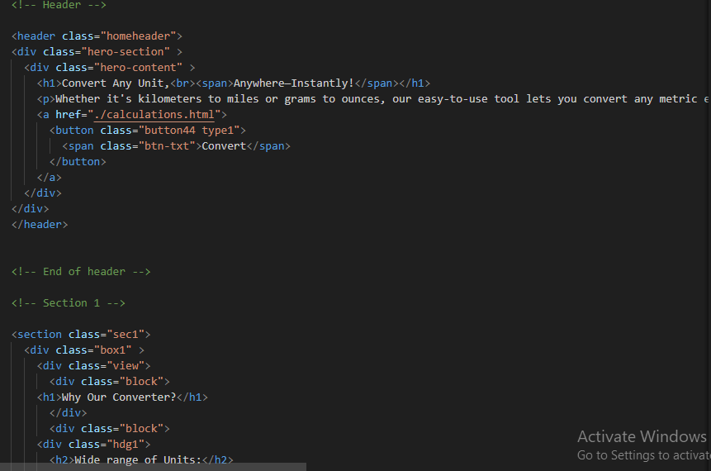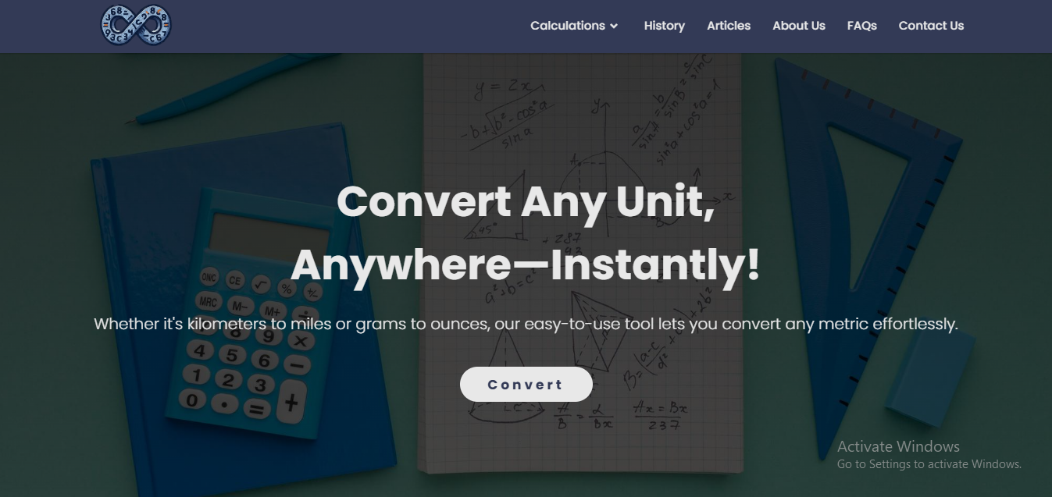

**Home Page**

**Source Code**

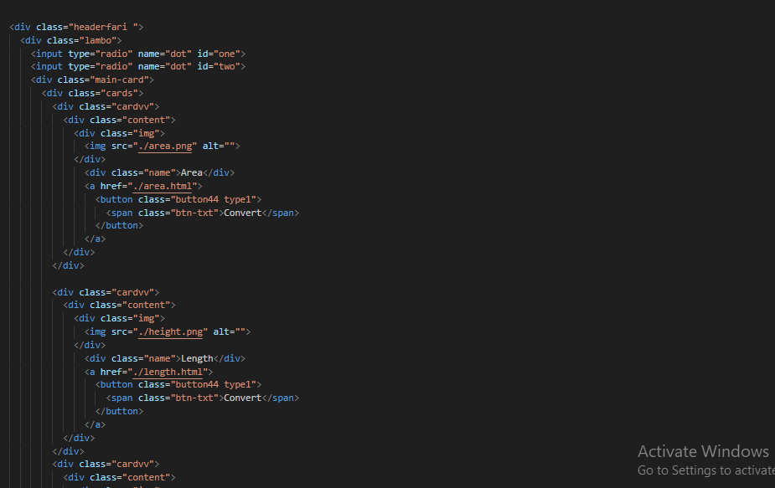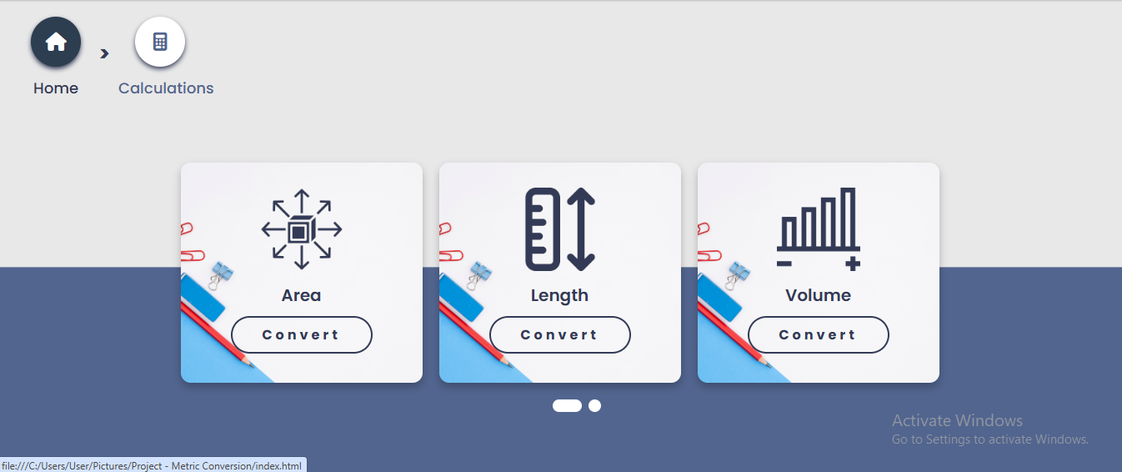

**Source Code**

**Calculation Page**

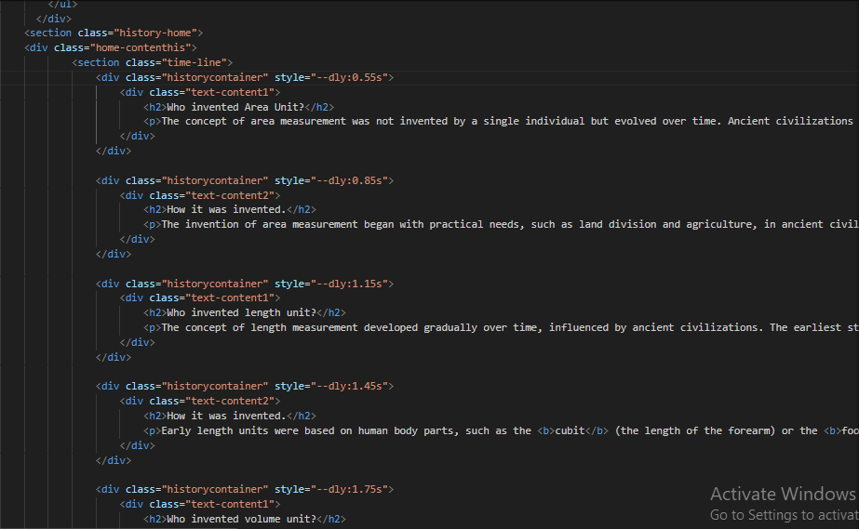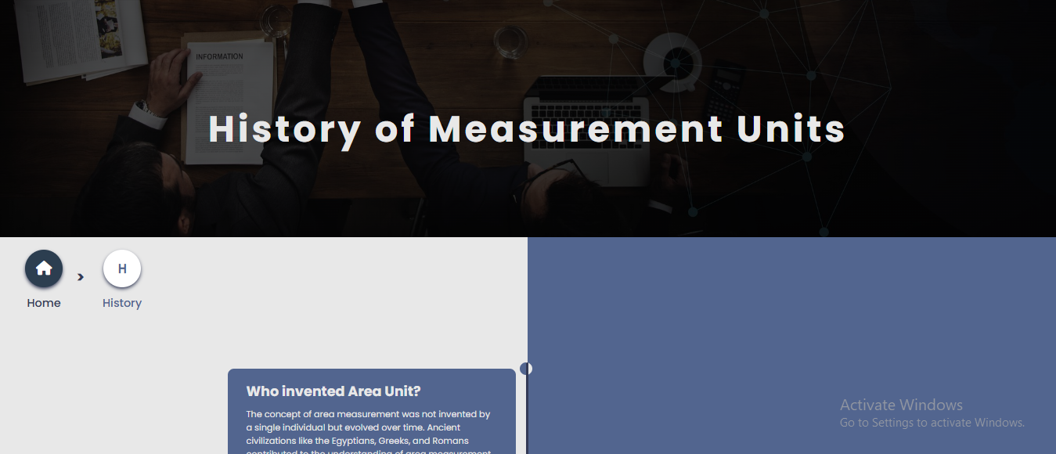

**History Page**

**Source Code**

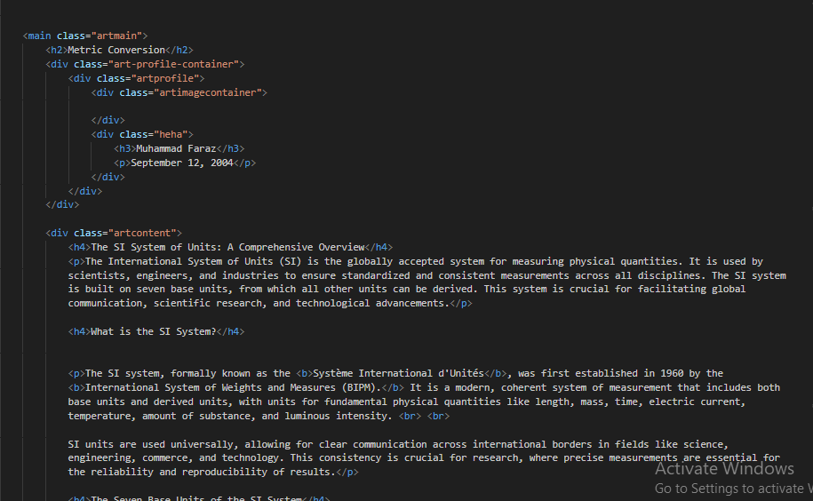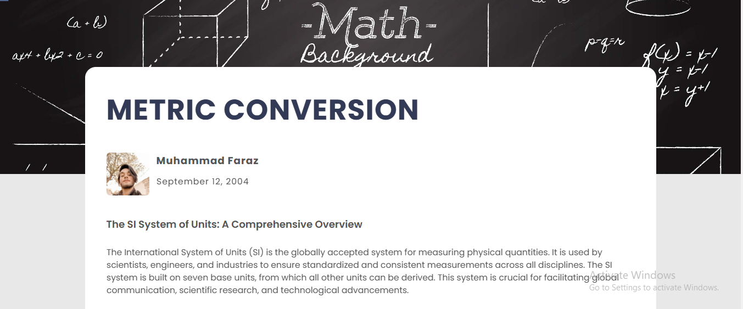

**Articles Page**

**Source Code**

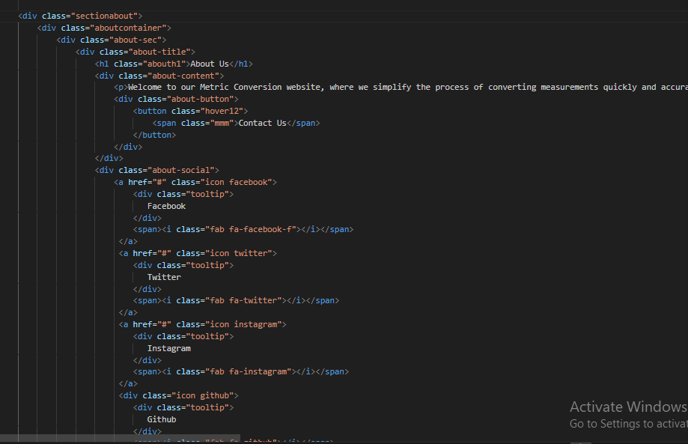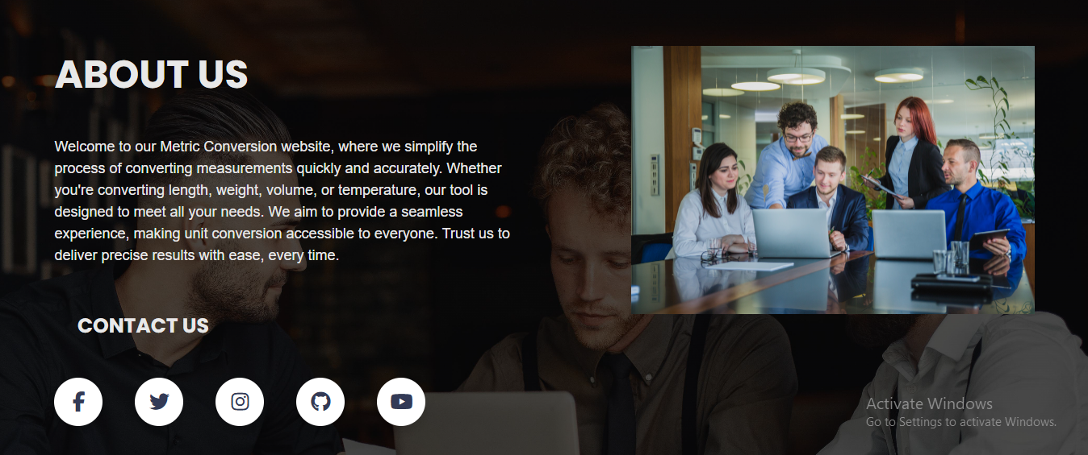

**About Us Page**

**Source Code**

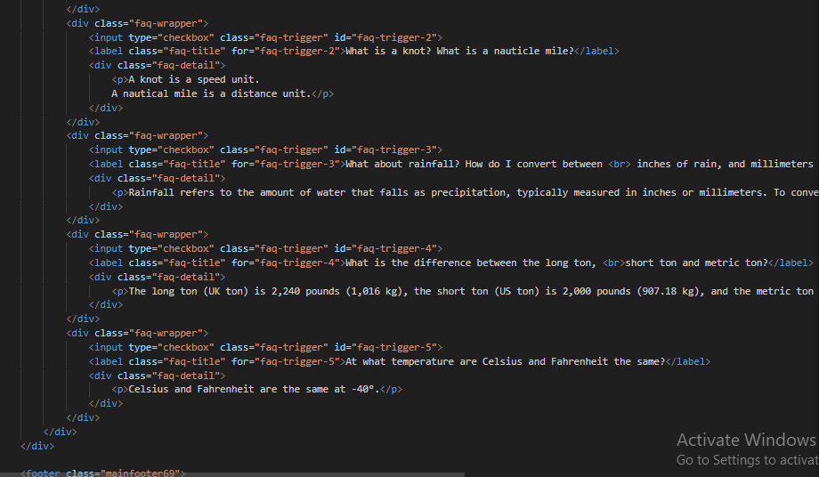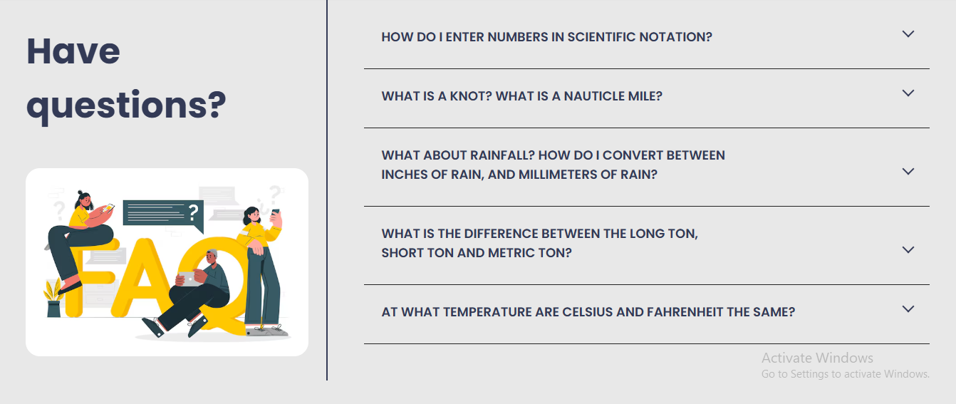

**FAQs Page**

**Source Code**

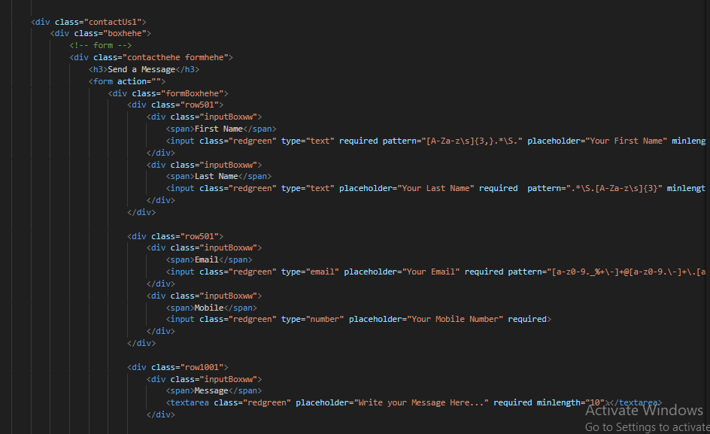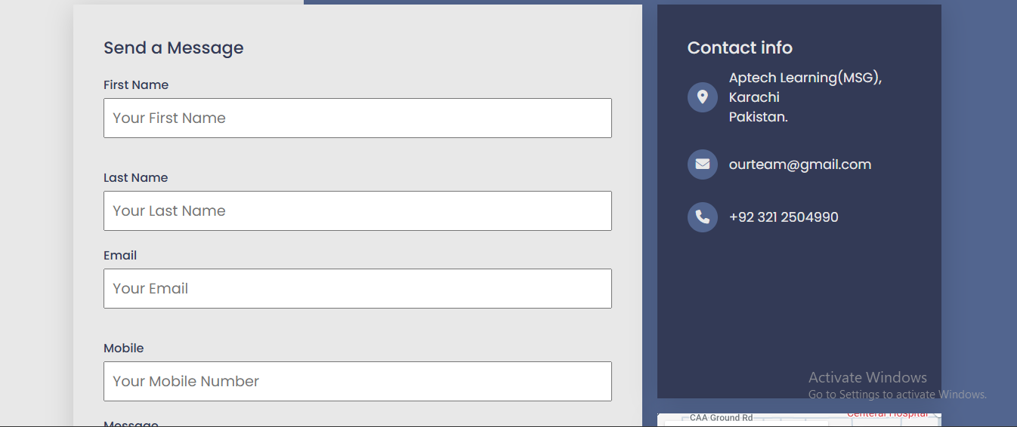

**Contact Us Page**

**Source Code**

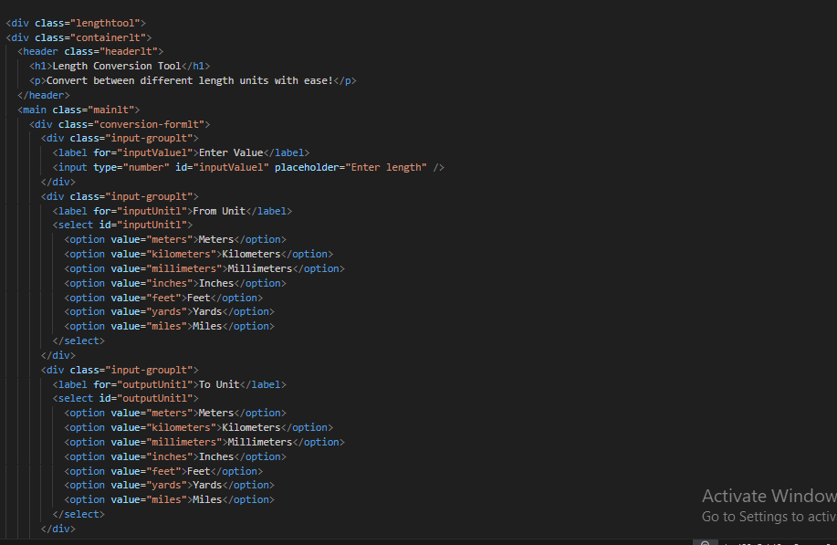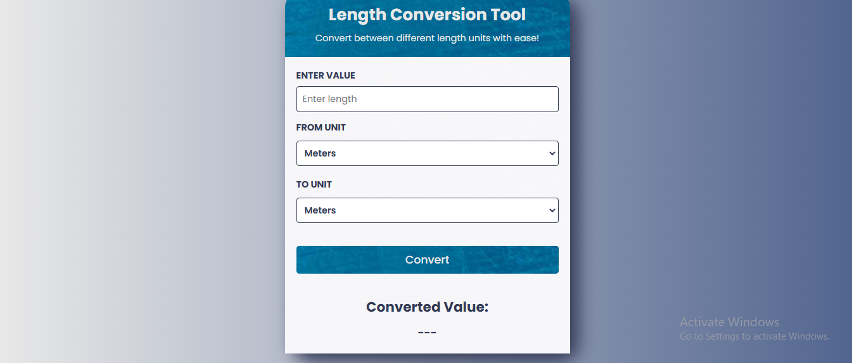

**Length Page**

**Source Code**